APPLICATIONS MUST BE SUBMITTED BY FEBRUARY 20, 2020

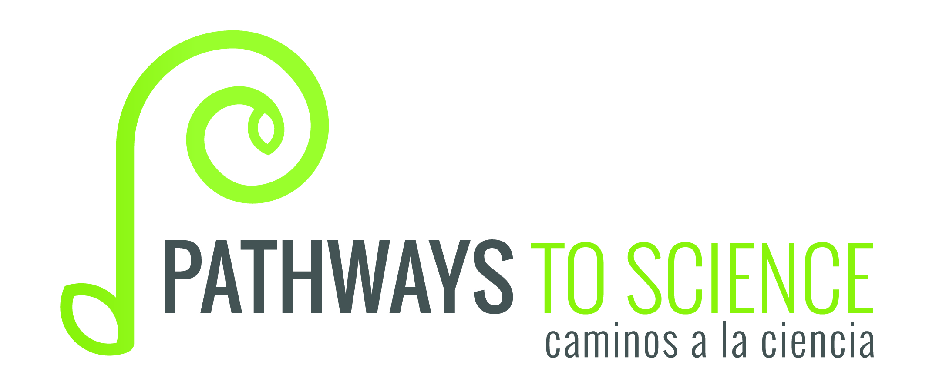

Caminos a la Ciencia
Student Application
2020

STUDENT INFORMATION
Please print:

Name ___________________________________________ Date of birth ______________________

Current mailing address_______________________________________________________________
street city state zip

Email address: ______________________________________ Country of Citizenship: _____________

Current Grade: Freshman
Sophomore
Other ________________________________

Name of your high school ___________________________________________

Name of your guidance counselor _____________________________________

What STEM areas interest you? (check as many as apply)
Chemistry Biology Physics Engineering Math Environmental Science

Astronomy Earth Science Other _________________________

Current GPA: _________

List the lab science courses you have taken, with your grade:
____________________________________________________________________________________
____________________________________________________________________________________

What extracurricular activities do you participate in?
____________________________________________________________________________________________________________________________________________________________________________________________________________________________________________________________

Race/Ethnicity - Do you identify as Hispanic/Latino? Yes No

If chosen for our program, could you commit to attending the Caminos a la Ciencia summer camp at Randolph-Macon College from June 27-July 2, 2020? Yes No

References: Please provide the name of one reference from an individual who is not related to you who can provide information about your aptitude for science, your academic abilities, or both. Please have this individual e-mail a letter of recommendation to Molly Smith, Caminos a la Ciencia Program Coordinator, at mollysmith@rmc.edu.

Reference:
Name _______________________________Relationship to Applicant: ___________________
Email address: _________________________________ Phone: ________________________

Personal Essay: Please provide a personal essay. Your personal essay should specifically address the following questions:
- What is your particular science interest (chemistry, biology, or physics)? Why are you interested in this area?
- Why do you want to participate in the Caminos a la Ciencia summer residential experience?
Please type your essay and limit it to two double-spaced pages (500 words). Essays can be in English or in Spanish.
You can attach your essay to this document.

I pledge that the above information is true and complete to the best of my knowledge:

___________________________________
student signature

___________________________________
parent signature

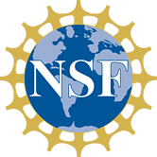
APPLICATIONS MUST BE SUBMITTED BY FEBRUARY 20, 2020

